Trevor Pirone

Professor Labouseur

Lab #9

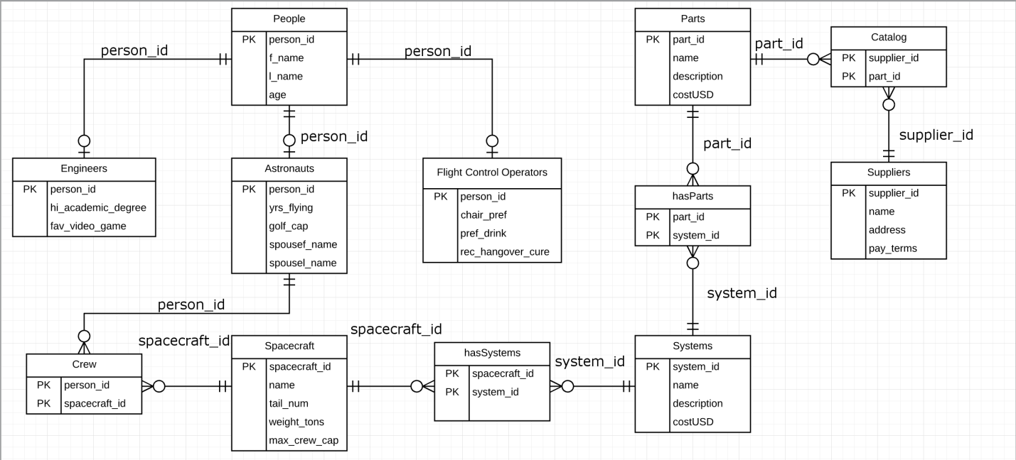**Normalization #3**

Functional Dependencies

The functional dependencies are as follows:

person_id 🡪 f_name, l_name, age

person_id 🡪 hi_academic_degree, fav_video_game

person_id 🡪 yrs_flying, golf_cap, spouse_name, spousel_name

person_id 🡪 chair_pref, pref_drink, rec_hangover_cure

person_id, spacecraft_id 🡪

spacecraft_id 🡪 name, tail_num, weight_tons, max_crew_cap

spacecraft_id, system_id 🡪

system_id 🡪 name, description, costUSD

part_id, system_id 🡪

part_id 🡪 name, description, costUSD

supplier_id, part_id 🡪

supplier_id 🡪 name, address, pay_terms

Boyce-Codd Normal Form

The ER diagram and database is currently in BNF. This is because it is in 1NF and it is atomic. It is in 2NF because it is in 1NF and everything is functionally dependent on the primary key without any repeating groups. It is in 3NF because it is in 2NF and there are no multi-key dependencies. Finally, it is in BNF because it is in 3NF and there are no transitive dependencies. Since the database is in 1NF, 2NF, and 3NF, by this proof, it implies that it must be in BNF.